**Lab**

**5**

1. List the user commands (files in /usr/bin) and redirect the output to /tmp/commands.list

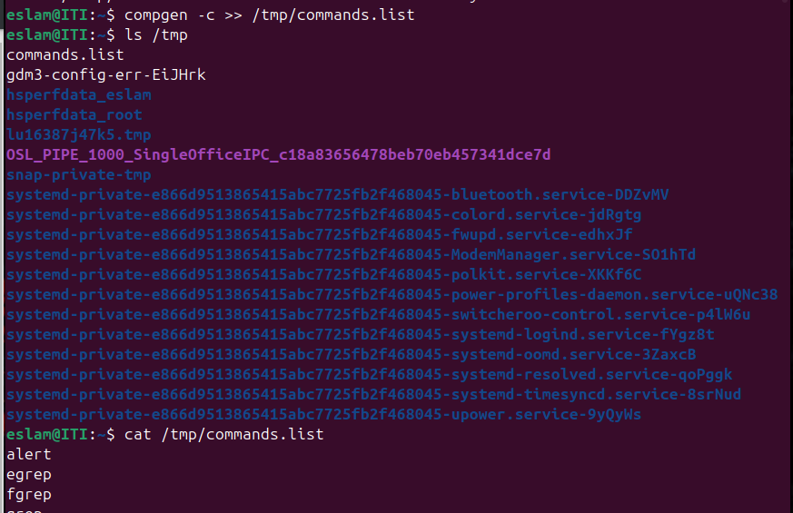

1. Compress a file by compress, gzip, pack, zip commands and decompress it again. State the differences between compress and gzip commands.

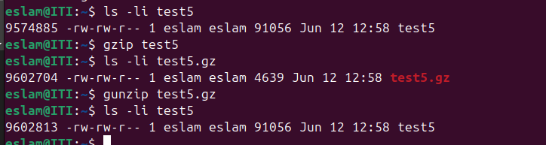

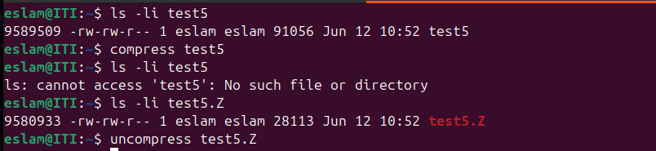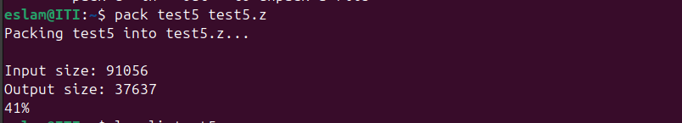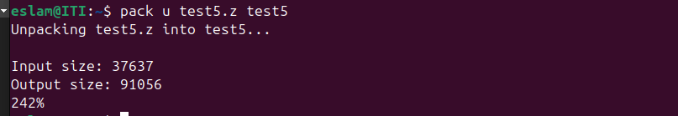

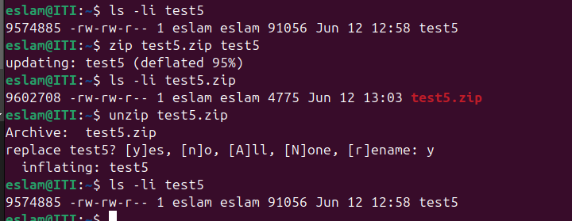

differences between compress and gzip commands? gzip generally achieves better compression ratios than compress, meaning it can reduce file sizes more effectively

1. What is the command used to view the content of a compressed file.

zcat

1. Backup /etc directory using tar utility.



1. Starting from your home directory, find all files that were modified in the last two day.



1. Starting from /etc, find files owned by root user.

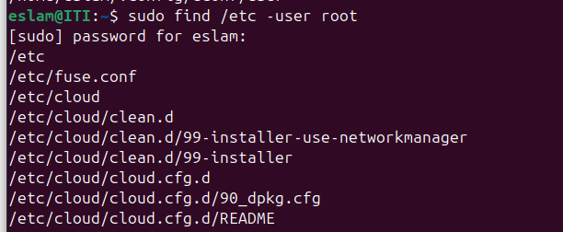

1. Find all directories in your home directory.



1. Write a command to search for all files on the system that, its name is “.profile”.

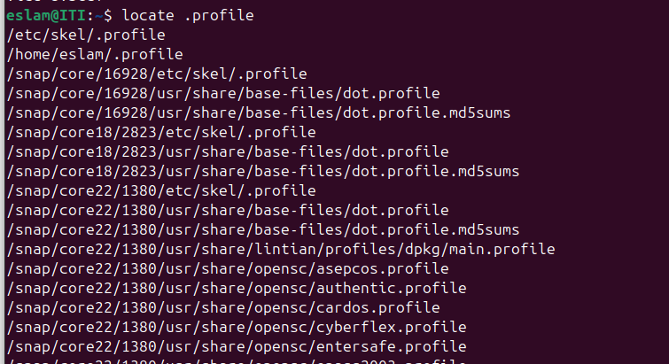

1. Identify the file types of the following: /etc/passwd, /dev/pts/0, /etc, /dev/sda.



/etc/passwd: flle -



/dev/pts/0: character special file c



/dev/sda: Block special file b

1. List the inode numbers of /, /etc, /etc/hosts.

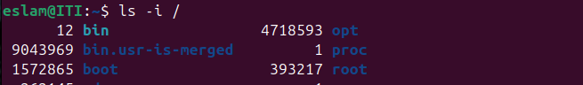

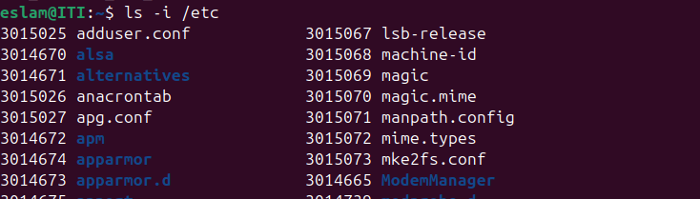



1. Copy /etc/passwd to your home directory, use the commands diff and cmp, and Edit in the file you copied, and then use these commands again, and check the output.

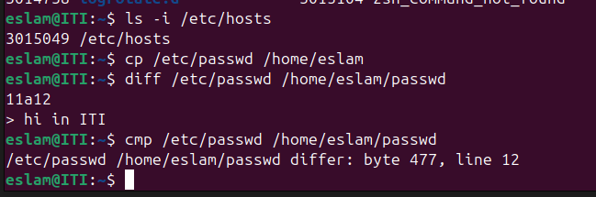

1. Create a symbolic link of /etc/passwd in /boot.

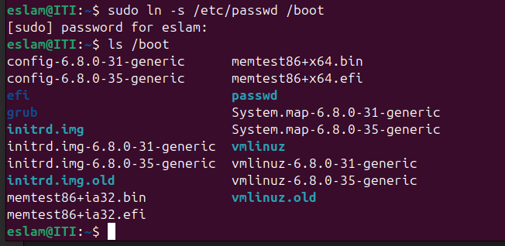

1. Create a hard link of /etc/passwd in /boot. Could you? Why?



-no, because hard link should be in same partition of original file

1. List the user commands that have set-uid permissions in the system.

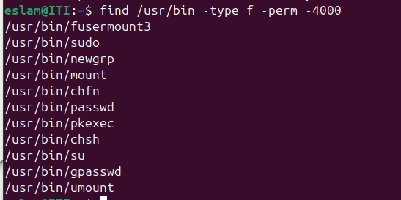

1. List the user commands that have set-gid permissions in the system.

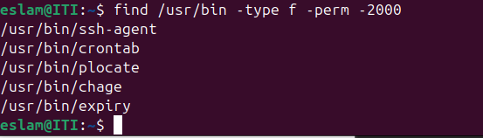

1. List the directories that have sticky-bit set in the system.

